Graphite and felt anodes for microbial fuel cells

by David Klein

Abstract

Further research into trying to understand microbial fuel cells, its limits and strengths, can be read in this paper. The anode material used in the cells, graphite fiber and felt, is the main variable studied in this experiment. Felt brush (ranging from 45-72 mV) is shown to produce an average seven times the voltage of graphite fiber brush (ranging from 4-10 mV). Basicity of the environment increased a significant amount over the experiment, conductivity had small increases, and ammonia concentrations decreased to about half their starting concentrations (from about 65ppm to about 15ppm). The geobacter exoelectrogen proteobacteria were absent from the carbon brush but existed on the felt brush. Based on this experiment the felt brush material seems to produce larger voltage. Other small conclusions can be drawn but more research is needed to understand some of the outcomes of this experiment.

Introduction

Energy collection by microbial fuel cell (MFC) is a renewable energy source that is rarely thought of outside of academia, but microbial fuel cells have been making progress outside of the public eye and hold much promise as an energy source combined with a wastewater treatment method. Microbial fuel cell research is still a science in its young years. It is only recently that they have been investigated and tested for potential use in wastewater treatment. Research in this field is steadily growing each year and there is still much to be understood. Many factors need to be tested, from solution to cell architecture, from electron conduction to microbial communities.

Previous research has laid a foundation for this experiment. Utilizing designs and methods from leading research in this field this experiment does further investigating, focusing on testing two different materials, graphite fiber and felt, for the anode portion of the cell (Logan 2007). Nutrient tests, acidity/basicity tests, voltage readings, and conductivity are measures utilized to investigate correlations between changing characteristics of the cell in this experiment. Furthermore, the geobacter proteobacteria have been shown in previous research to be exoelectrogens (Logan 2009). This means they are bacteria with the ability to transfer electrons extracellularly. This is an important trait needed for obtaining energy from microbial fuel cells. For this reason this bacteria is tested for in both cells throughout the experiment.

Materials and Methods

Similar to a chemical battery, the microbial fuel cells utilized an anode that accepts electrons from its environment and transports the electron to a cathode, and during this transfer the electricity of the electrons is captured for either use or measurement. There are many differences to a chemical battery but the underlying foundation is the same.

In this case the cells have bacteria living in the environment and on the anode. The bacteria consumes organic material that we feed it, this food is in the form of wastewater and essential vitamins and nutrients. During their metabolism they release carbon dioxide, protons, and electrons. The bacteria living on the anode use the anode as a final electron acceptor for some of the energy they produce. This electron travels out of the cell on a wire to the cathode. While out of the cell we measure the voltage. The cathode is open on one side to the outside environment and the other side is in the microbial fuel cell. When the electron reaches the cathode it combines with oxygen from the outside environment and a proton from the microbial fuel cell to produce water.

The cells hold approximately 160mL each. One cell used a carbon graphite fiber brush as the anode and the other cell used a felt brush as the anode. At the beginning the cells are filled with 10% wastewater and 90% phosphate buffer solution, this PBS had the following recipe: Na2HPO4 (4.09 g/L), NaH2PO4‚H2O (2.93 g/L), NH4Cl (0.31 g/L), KCl (0.13 g/L), and metal salt (12.5 mL/L). Subsequent feedings utilized the following recipe: Trace Elements (1mL/L), Vitamins (5mL/L), Acetate (3M, 26millimoles), wastewater (40mL/L), and PBS (remaining). When voltage for the cells dropped below average levels this was an indication that food was needed, and thus administered, to keep the bacteria fed and producing energy. An example of a cell reaching steady state can be seen in Figure 1. Reaching a steady state of voltage with the cell at hand was an important part of the experiment because it gives a solid idea on the normal energy potential attainable and sustainable over a long period of time along with its other characteristics such nutrient availability, existing microbial communities, conductivity, and other measurements.

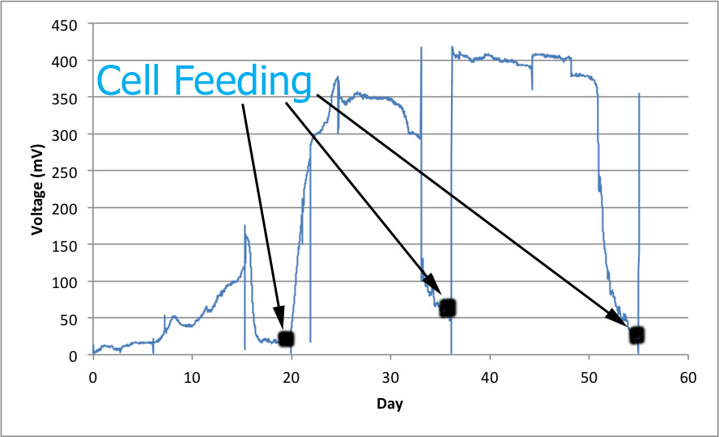

Figure 1: An example of how reaching a steady state is seen in a real experiment, using researcher Keren Golub’s cell #1, felt brush with bicarbonate buffer solution.

There were a number of different measurements taken of the cells. To quantify the energy each cell’s anode-cathode connection ran through a circuit that measured the voltage. Periodically and every time food was administered samples were taken of the cells. With these samples pH and conductivity were measured. Some samples were also sent off to another lab for chemical oxygen demand measurements to be taken, a useful measure of water quality.

Ammonium is one of the nutrients that existed in the environment. Some sample was filtered and used to measure ammonium concentration. Knowing the absorbances of some standard ammonium concentrations allowed interpolation of the concentrations of samples by using the samples’ absorbances.

Looking for existence of some known exoelectrogens was a goal pursued by simple PCR and gel electrophoresis using DNA from the cells taken at different times and specific primers for these exoelectrogens. Primers Universal 16S, Geo564F, and Geo840R were purchased from Integrated DNA Technologies (IDT). DNA was extracted from the cells at many different time points using the MO Bio Power Soil kit, which involves lysis of cells, precipitation of non-DNA material, capture of DNA on silica membranes, and removal of DNA by salt solution.

For the universal primers the following PCR reaction schedule was run: 3 minutes at 95°C, 25 cycles of 15 seconds at 95°C to 15 seconds at 53°C to 15 seconds at 72°C, then 30 seconds at 72°C. For the geobacter primers the following PCR reaction schedule was run: 3 minutes at 95°C, 32 cycles of 15 seconds at 95°C to 15 seconds at 59°C to 5 seconds at 72°C, then 20 seconds at 72°C. For the semi-quantitative PCR the geobacter primers were used and the same geobacter reaction schedule was followed but samples were taken after cycle 28, 30, 32, and 34.

Results

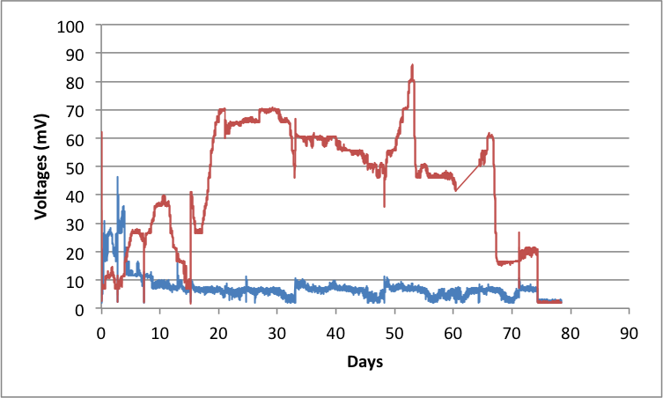

Figure 2: Voltages for cell 7 (Blue) and cell 8 (Red).

Voltage was the main measure of this experiment and is shown in Figure 2. Voltage for cell 7, the graphite fiber brush anode cell, seemed to reach a steady state after around 20 days of operation. The steady state voltage varied within the range of 45 mV and 72 mV. Its voltage started out low as expected and grew steadily to a steady range, which it held for the majority of the time. Around day 53, as the experiment was coming to an end, the cell began to fail. Even after feeding the previous steady state voltage could not be achieved before the experiment had to come to an end. Voltage for cell 8, the felt brush anode cell, seemed to reach a steady state rapidly, after around 7 days of operation. The steady state voltage had a very limited range, varying within the range of 4 mV and 10 mV. Strangely, the voltage started high, within the range of 20 mV and 35 mV, and soon decreased to the low state it maintained until the end of the experiment.

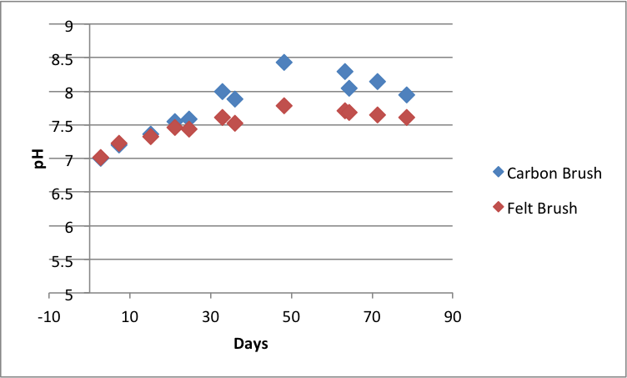

Figure 3: pH data for both cells.

The pH levels of both cells were measured at several time points. Data is shown in Figure 3. Sampling was done of the bulk liquid, not a specific domain of the cell. Had sampling been done of a number of different domains of the cell we would see differences, for example the area near the cathode would be expected to show more acidity as that is where the reduction reaction is occurring. Based on this data both cells seemed to have their basicity increase to a noteworthy degree. The carbon brush has large increases in pH near the end, almost a pH degree higher than the felt brush. These pH increases are surprising because normally one would not expect to see such large increases when using a phosphate buffer solution, which is supposed to maintain a stable pH. The last few measurements do show the pH leveling off, which might indicate a steady state being formed similar to how the voltage reaches a steady state.

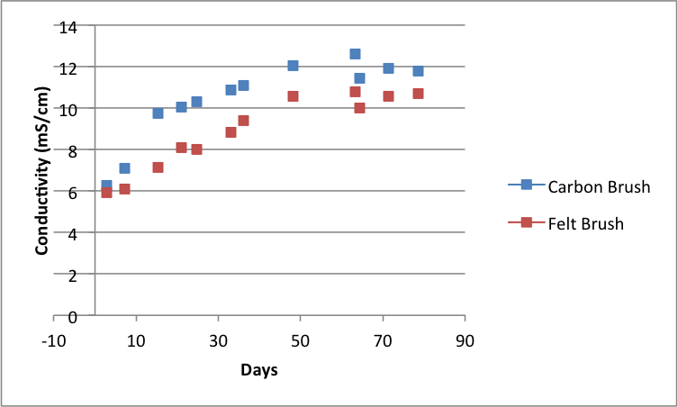

Figure 4: Conductivity data measured in mS/cm for both cells.

Both cells had increases in conductivity, a good sign when the goal of microbial fuel cells is to extract energy from natural biological reactions. This data is exhibited in Figure 4. Having exoelectrogens and an environment that are measured to conduct electricity well give hope for better power density and energy production. Surprisingly, the carbon brush had the higher conductivity readings even though its voltage readings were much lower than those of the felt brush. Even though conductivity can hint at energy production, it is possible to have totally different measurements for conductivity and voltage. Even though the bacteria and materials in the environment of the cell might conduct electricity well the final electron acceptor for bacterial metabolic pathways may not be anode and may instead be oxygen or other molecules, leaving the anode without electrons for us to measure or use. But the differences in conductivity between the carbon brush and felt brush were not very significant even though the voltages may have been. The last few measurements do show the conductivity leveling off, possibly reaching a steady state.

Nutrient levels for ammonium were tested and can be seen in Figure 5. Both cells had their concentrations of ammonium decrease as time went on. This is a good sign because if this microbial fuel cell method were to be used in a wastewater treatment plant we would want cleaner water to be produced so less cleaning would need to be done before the water can be released back into the natural environment. High levels of nutrients can cause eutrophication and cause harm to natural environments if left at high levels without dilution and treatment. The carbon brush cell decreased to a slightly larger extent than the felt brush cell. Both cells decreased to almost half their starting levels, an impressive achievement. Had the experiment continued further decrease may have been observed but this may have had detrimental affects to the microbial communities that rely on certain nutrients for survival. We do see a leveling off of nutrients at the end so a steady state of nutrient levels may have been found.

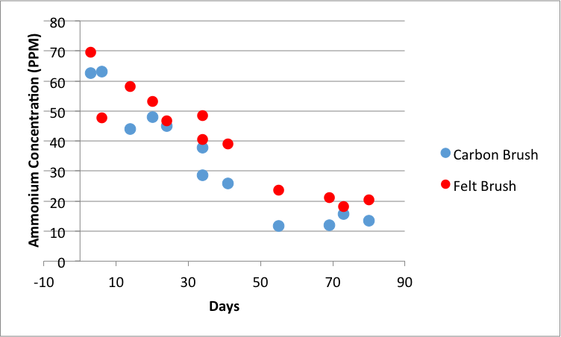

Figure 5: Nutrient content for ammonium in both cells, measured in parts per million.

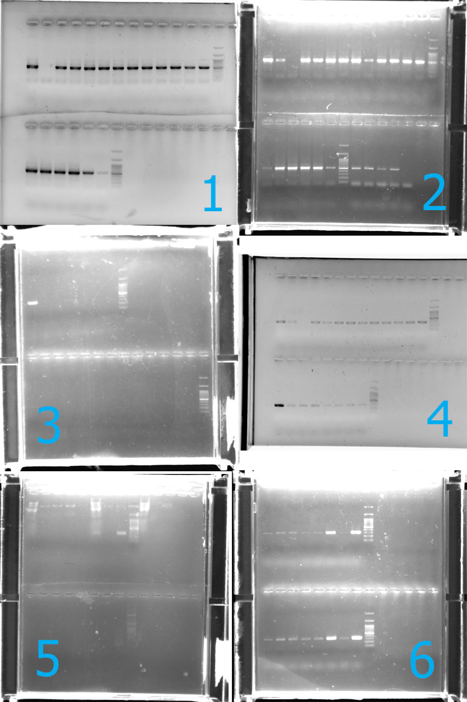

Figure 6: PCRs with Universal primers for graphite anode (1) and felt anode (2), PCRs with Geobacter primers for graphite anode (3) and felt anode (4), and semi-quantitative PCR for felt anode after 28 and 30 cycles (5), then 32 and 34 cycles (6).

Polymerase chain reactions were run to test for a specific exoelectrogen family, the Geobacter proteobacteria, as seen in Figure 6. The universal primers that bind to DNA of general bacteria came out as expected for both graphite and felt anode cells. Both cells showed plenty of bacterial growth. The geobacter primers had differing results. The graphite anode cell showed no growth of geobacter bacteria using these primers. The felt anode cell showed some growth of geobacter. A semi-quantitative PCR was run on the felt anode cell for more information on its growth. The results were smeared and hard to see in the samples taken after cycles 28 and 30, but the results were better in the samples taken after cycles 32 and 34. The results showed more growth of geobacter bacteria on the anode than in the liquid of the cell. There was growth of bacteria when compared to cell 2 of fellow researcher Keren Golub’s experiment the degree of growth was much lower. Keren’s cell, using felt anode and bicarbonate buffer, displays voltage about 7 times larger than the felt anode of this experiment and also had much more geobacter bacterial growth.

Discussion

When comparing the results received in this experiment to results of similar microbial fuel cell research experiments similarities are found and conclusions point in the same direction. Looking at the differences in energy achievement between the two anode types there is evidence that felt anode produces much higher voltage than graphite fiber brush. One survey of anode materials and their produced power densities had results showing 238% higher power density (measured in mW m2) for felt brush anode compared to graphite fiber brush anode material (Zhou et al.). The steady state voltages of this experiment show the felt brush produced about seven times higher voltage measurements in the felt brush anode compared to the graphite fiber brush anode. It seemed as if the outcomes of this experiment followed the general conclusions and complemented the work of other experiments.

The phosphate buffer used in this experiment is a common buffer for maintaining pH and allowing for high conductivity, but it is not the only buffer possible. Another popular buffer used is a bicarbonate buffer solution (Fan et al.). This experiment was run in a lab where other such microbial fuel cell experiments were being run, including cells that used bicarbonate buffer solution. Those cells had much higher power outputs than the cells of this experiment, and that is expected based on previous research. One such study showed power densities (measured in mW m2) for bicarbonate buffer solutions to be about 138% stronger than power densities for phosphate buffer solutions. The other microbial fuel cell experiments run in the same lab as this experiment showed bicarbonate buffer solution cells producing around six times more voltage than the phosphate buffer solution cells of this experiment. This can be seen in Figure 7.

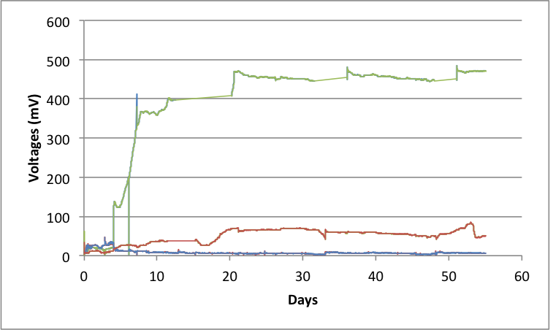

Figure 7: Green represents a bicarbonate buffer solution cell (cell 5) of researcher Keren Golub’s experiment, Blue and Red represent cell 7 and 8 respectively of this experiment using phosphate buffer solution.

When looking at the PCR results we have to keep in mind that the Geobacter primers could also catch bacteria related or similar to the geobacter group. We only assume geobacter for felt brush but more detailed DNA tests would need to be run to be sure. The cause for the higher levels of voltage from the felt brush could be because of the presence of more geobacter exoelectrogens, it could be another type of exoelectrogen similar to geobacter that is amplified by the same primers, or there could be no correlation. When comparing the voltage and amplification of geobacter for the cells of this experiment to the felt anode, bicarbonate buffer, cell 2 of Keren Golub’s experiment this correlation does fit. Her cell has a higher presence of the bacteria and higher voltage. For the purposes of this experiment we can assume it is geobacter that is caught, but we cannot assume their higher presence is the cause of the higher voltage without further tests.

This experiment brought about more questions than answers. Further experiments need to be made to figure out why nutrient concentrations dropped, why basicity increased, why conductivity was higher for the lower voltage cell, and if geobacter bacteria presence is the cause of the higher voltage. This experiment did conclude that felt brush produces a higher voltage than graphite fiber brush, at least under these conditions.

Acknowledgements

This experiment could not have been completed without the help of Keren Golub and Neta Altman.

Works Cited

Logan, B. E., Cheng, S., Watson, V. & Estadt, G. Graphite fiber brush anodes for increased power production in air-cathode microbial fuel cells. *Environ. Sci. Technol.*2007.

Logan, B. E. Exoelectrogenic bacteria that power microbial fuel cells. *Nature Rev. Microbiol.* 2009.

Zhou M, Chi M, Luo J, He H, Jin T (2011) An overview of electrode materials in microbial fuel cells. J Power Sources. doi: 10.1016/j.jpowsour.2011.01.012

Fan, Y. Z.; Hu, H. Q.; Liu, H. Sustainable power generation in microbial fuel cells using bicarbonate buffer and proton transfer mechanisms *Environ. Sci. Technol.* 2007.